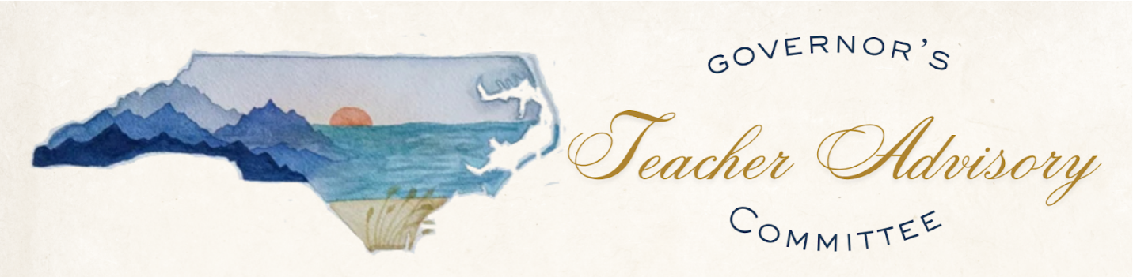
GOVERNOR’S TEACHER ADVISORY COMMITTEE
Tuesday, April 28, 2025 | 10:00 AM – 12:30 PM
Virtual – Microsoft Teams
Chair: Rachel Candaso

WELCOME 10 Min
Chair Greetings
Previous Meeting Feedback
Desired Outcomes & Agenda
Conflict of Interest

LEARNING 70 Min
Governor’s Staff Legislative Update 10 Min
NC Collabratory Teacher Retention 60 Min
ADVOCACY 60 Min
Members Small Group Work 45 Min
Community Work 15 Min

CLOSING 10 Min
Chair Public Comment
Closing Comments & Next Meeting Reminder

Conflict of Interest Statement: In accordance with the State Government Ethics Act, it is the duty of every Advisory Council member to avoid both conflicts of interest and the appearance of conflicts of interest. If any Advisory Council member has any known conflict of interest or is aware of facts that might create the appearance of such conflict, with respect to any matters coming before the Advisory Council today, please identify the conflict or the facts that might create the appearance of a conflict to ensure that any inappropriate participation in that matter may be avoided. If at any time, any new matter raises a conflict during the meeting, please be sure to identify it at that time.

