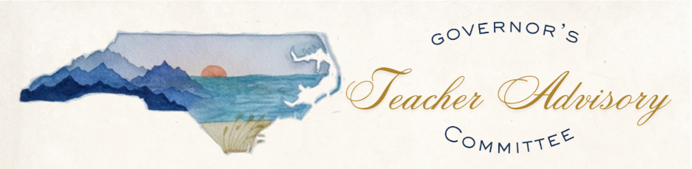

Governor’s Teacher Advisory Committee
Meeting Agenda

Tuesday, July 28, 2026
10:00 AM – 12:30 PM
Albemarle Building, 325 N. Salisbury Street, Raleigh, NC | Room 240
Chair: Rachel Candaso

Welcome – 30 Minutes
- Greetings (Chair)
- New Member Introductions and Swearing In
- Previous Meeting Feedback
- Desired Outcomes and Agenda Overview
- Conflict of Interest Statement

Learning – 70 Minutes

Legislative Update – 10 Minutes
Presenter: Governor’s Staff

Championing Public Schools – 60 Minutes
Presenter: Public School Forum

Advocacy – 60 Minutes

Small Group Work – 45 Minutes
Participants: Members

Community Work – 15 Minutes
Participants: Members

Closing – 10 Minutes
- Public Comment (Chair)
- Closing Comments
- Next Meeting Reminder

Conflict of Interest Statement
In accordance with the State Government Ethics Act, it is the duty of every Advisory Council member to avoid both conflicts of interest and the appearance of conflicts of interest. If any Advisory Council member has any known conflict of interest or is aware of facts that might create the appearance of such conflict, with respect to any matters coming before the Advisory Council today, please identify the conflict or the facts that might create the appearance of a conflict to ensure that any inappropriate participation in that matter may be avoided. If at any time, any new matter raises a conflict during the meeting, please be sure to identify it at that time.

